**Role Management - PCAL**

**PCAL Role Matrix**

|  |  |  |  |  |  |  |  |
| --- | --- | --- | --- | --- | --- | --- | --- |
| # | Roles /  Team Names | PCAL View Adjustment Transaction | PCAL Run Report | PCAL Authorize  Adjustment  Transaction | PCAL Process Adjustment  Transaction | PCAL Settings | PCAL Search |
| 1 | PCAL_GeneralUsers_Inv_ASL | Yes | Yes |  |  |  | Yes |
| 2 | PCAL_Authorizer_Inv_ASL | Yes | Yes | Yes |  |  | Yes |
| 3 | PCAL_Processor_Inv_ASL | Yes | Yes |  | Yes |  | Yes |
| 4 | PCAL_Admin_Inv_ASL | Yes | Yes | Yes | Yes | Yes | Yes |
| 5 | PCAL_GeneralUsers_ACBS | Yes | Yes |  |  |  | Yes |
| 6 | PCAL_Authorizer_ACBS | Yes | Yes | Yes |  |  | Yes |
| 7 | PCAL_Processor_ ACBS | Yes | Yes |  | Yes |  | Yes |
| 8 | PCAL_Admin_ ACBS | Yes | Yes | Yes | Yes | Yes | Yes |
| 9 | PCAL_GeneralUsers_FTS | Yes | Yes |  |  |  | Yes |
| 10 | PCAL_Authorizer_FTS | Yes | Yes | Yes |  |  | Yes |
| 11 | PCAL_Processor_ FTS | Yes | Yes |  | Yes |  | Yes |
| 12 | PCAL_Admin_ FTS | Yes | Yes | Yes | Yes | Yes | Yes |
| 13 | PCAL_GeneralUsers_IPAR | Yes | Yes |  |  |  | Yes |
| 14 | PCAL_Authorizer_IPAR | Yes | Yes | Yes |  |  | Yes |
| 15 | PCAL_Processor_ IPAR | Yes | Yes |  | Yes |  | Yes |
| 16 | PCAL_Admin_ IPAR | Yes | Yes | Yes | Yes | Yes | Yes |

Note: Each of the PCAL source system will have separate set of roles. There will be 4 set of Roles/Teams (for each Source System categorized as General User, Authorizer, Processor and Admin

The PCAL Actions / Permissions are

* PCAL View Adjustment Transaction
* PCAL Authorize Adjustment Transaction
* PCAL Process Adjustment Transaction
* PCAL Run Report
* PCAL Settings
* PCAL Search

**Options for Role Management data setup**

**Option 1 –** Thru CRM

Setup the users, teams and modules from CRM portal

**Option 2 –** Thru Scripts

Setup the users, teams and modules thru scripts

**Option – 1 - Setup the users, teams and modules from CRM portal**

1. **Add User**

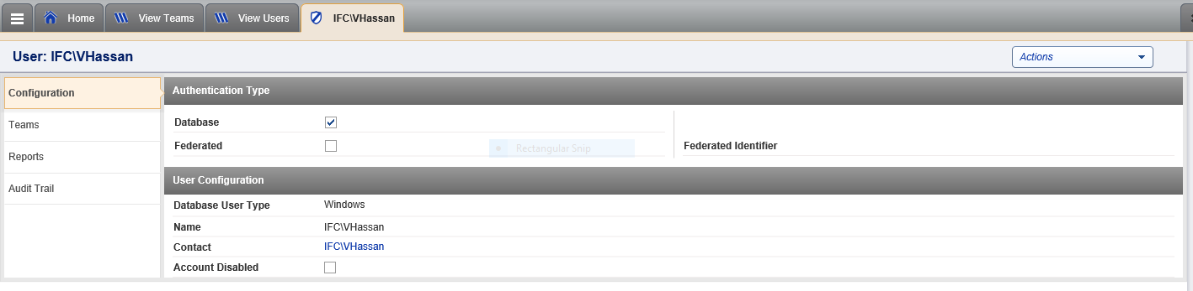

Data will be stored in dbo.TS_User

View Users

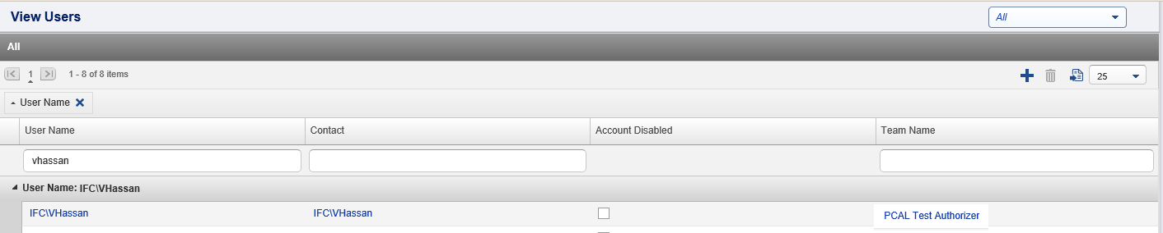

1. **Add Teams**

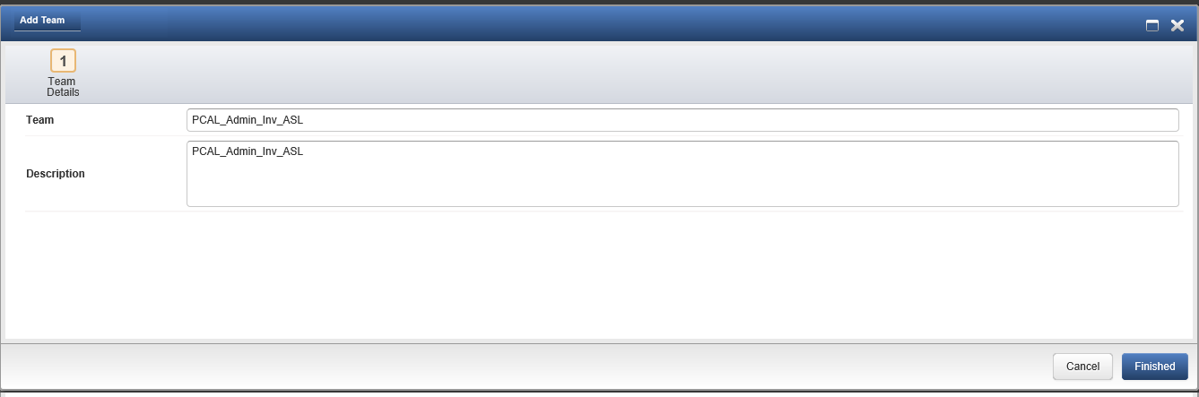

Data will be stored in dbo.TS_Teams

View Teams (after adding all the teams)

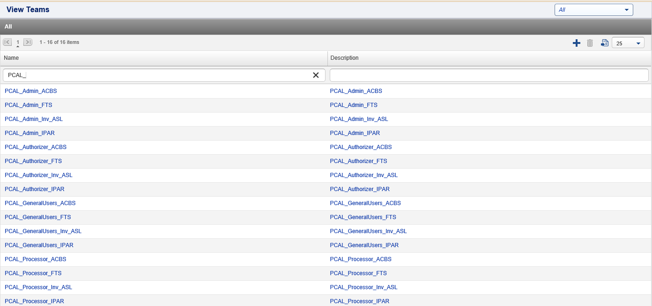

Associate User with Team

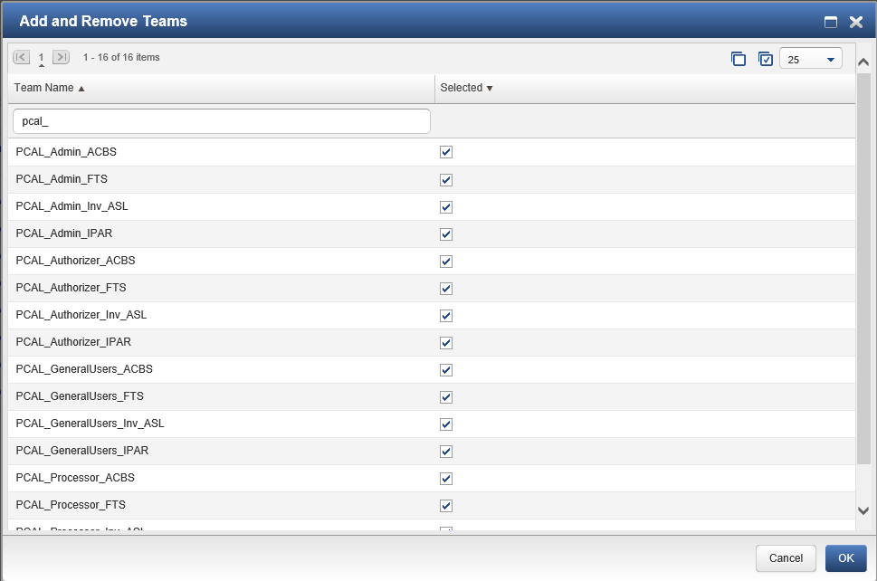

Role/Team – Users View

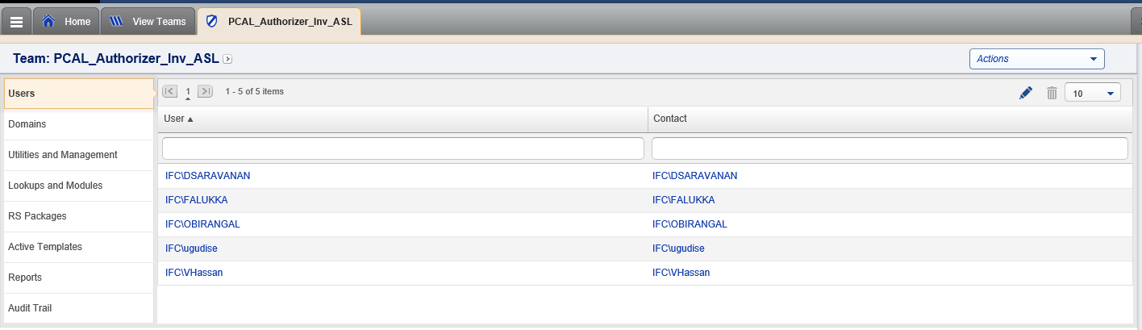

1. **Team – Utilities and Management** (Action / Permission)

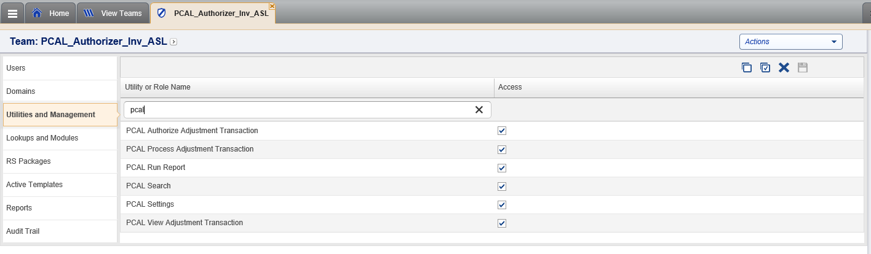

Data stored in dbo.TS_Modules

Data to be inserted with the column ‘dataOrActionModule’ set to 0

All the rows having **0** value in the **‘**dataOrActionModule’ column will appear in this screen.

If the ‘dataOrActionModule’ =2, then it will appear in the Lookup & Modules.

This will have the availableRights = 4

When the Access is set by selecting the check box, it will insert a record in the dbo.TS_Entitlements table

with DomainID = -1 (Investran Global)

We need to know the significance or the values 0, 1, 2 in the dataOrActionModule column.

1. Team – Lookups & Modules

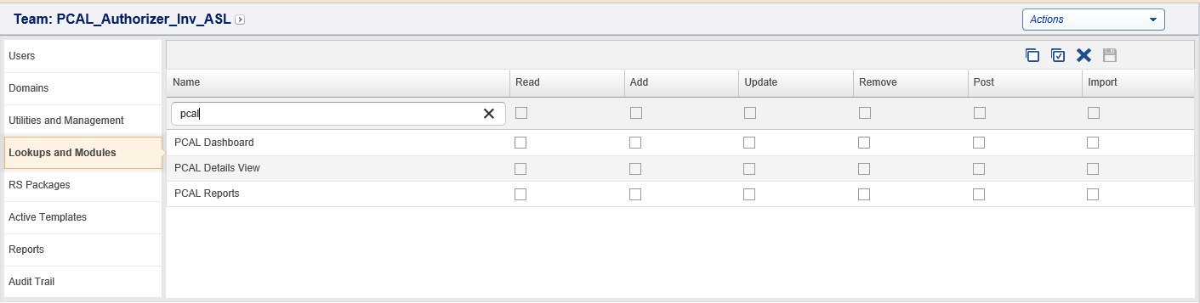

Data stored in dbo.TS_Modules

Data to be inserted with the column ‘dataOrActionModule’ set to 2

The Read, Add, Update, Remove, Post and Import permissions to be set by checking the relevant check boxes and saving.

This will set the respective flag in the database to 1 for the checked permission and 0 for the unchecked permission

This will be stored in the dbo.TS_Entitlements with EntitlementType=2

Domain Id = -1 (Investran Global)

We assume that we have to set the value of dataOrActionModule = 2 so that all the PCAL related modules will appear under Lookup & Modules.

**Option 2 – Thru Scripts - Setup the users, teams and modules thru scripts**

|  |  |
| --- | --- |
|  |  |
| **[dbo].[TS_User]** | We think that there is no need to insert users and this step will be done by the Admin from the CRM screen |
| **[dbo].[TS_Teams]** | **Investran and ASL**  insert into [dbo].[TS_Teams] (teamName,teamDescription, CreatedDate, CreatedBy, ChangedDate, ChangedBy) values  ('PCAL_Authorizer_Inv_ASL', 'PCAL_Authorizer_Inv_ASL', getdate(),'ifc\vhassan',getdate(),'ifc\vhassan')  insert into [dbo].[TS_Teams] (teamName,teamDescription, CreatedDate, CreatedBy, ChangedDate, ChangedBy) values  ('PCAL_Processor_Inv_ASL', 'PCAL_Processor_Inv_ASL', getdate(),'ifc\vhassan',getdate(),'ifc\vhassan')  insert into [dbo].[TS_Teams] (teamName,teamDescription, CreatedDate, CreatedBy, ChangedDate, ChangedBy) values  ('PCAL_Admin_Inv_ASL', 'PCAL_Admin_Inv_ASL', getdate(),'ifc\vhassan',getdate(),'ifc\vhassan')  insert into [dbo].[TS_Teams] (teamName,teamDescription, CreatedDate, CreatedBy, ChangedDate, ChangedBy) values  ('PCAL_GeneralUsers_Inv_ASL', 'PCAL_GeneralUsers_Inv_ASL', getdate(),'ifc\vhassan',getdate(),'ifc\vhassan')  **ACBS**  insert into [dbo].[TS_Teams] (teamName,teamDescription, CreatedDate, CreatedBy, ChangedDate, ChangedBy) values  ('PCAL_GeneralUsers_ACBS', 'PCAL_GeneralUsers_ACBS', getdate(),'ifc\vhassan',getdate(),'ifc\vhassan')  insert into [dbo].[TS_Teams] (teamName,teamDescription, CreatedDate, CreatedBy, ChangedDate, ChangedBy) values  ('PCAL_Authorizer_ACBS', 'PCAL_Authorizer_ACBS', getdate(),'ifc\vhassan',getdate(),'ifc\vhassan')  insert into [dbo].[TS_Teams] (teamName,teamDescription, CreatedDate, CreatedBy, ChangedDate, ChangedBy) values  ('PCAL_Processor_ACBS', 'PCAL_Processor_ACBS', getdate(),'ifc\vhassan',getdate(),'ifc\vhassan')  insert into [dbo].[TS_Teams] (teamName,teamDescription, CreatedDate, CreatedBy, ChangedDate, ChangedBy) values  ('PCAL_Admin_ACBS', 'PCAL_Admin_ACBS', getdate(),'ifc\vhassan',getdate(),'ifc\vhassan')  **FTS**  insert into [dbo].[TS_Teams] (teamName,teamDescription, CreatedDate, CreatedBy, ChangedDate, ChangedBy) values  ('PCAL_GeneralUsers_FTS', 'PCAL_GeneralUsers_FTS', getdate(),'ifc\vhassan',getdate(),'ifc\vhassan')  insert into [dbo].[TS_Teams] (teamName,teamDescription, CreatedDate, CreatedBy, ChangedDate, ChangedBy) values  ('PCAL_Authorizer_FTS', 'PCAL_Authorizer_FTS', getdate(),'ifc\vhassan',getdate(),'ifc\vhassan')  insert into [dbo].[TS_Teams] (teamName,teamDescription, CreatedDate, CreatedBy, ChangedDate, ChangedBy) values  ('PCAL_Processor_FTS', 'PCAL_Processor_FTS', getdate(),'ifc\vhassan',getdate(),'ifc\vhassan')  insert into [dbo].[TS_Teams] (teamName,teamDescription, CreatedDate, CreatedBy, ChangedDate, ChangedBy) values  ('PCAL_Admin_FTS', 'PCAL_Admin_FTS', getdate(),'ifc\vhassan',getdate(),'ifc\vhassan')  **IPAR**  insert into [dbo].[TS_Teams] (teamName,teamDescription, CreatedDate, CreatedBy, ChangedDate, ChangedBy) values  ('PCAL_GeneralUsers_IPAR', 'PCAL_GeneralUsers_IPAR', getdate(),'ifc\vhassan',getdate(),'ifc\vhassan')  insert into [dbo].[TS_Teams] (teamName,teamDescription, CreatedDate, CreatedBy, ChangedDate, ChangedBy) values  ('PCAL_Authorizer_IPAR', 'PCAL_Authorizer_IPAR', getdate(),'ifc\vhassan',getdate(),'ifc\vhassan')  insert into [dbo].[TS_Teams] (teamName,teamDescription, CreatedDate, CreatedBy, ChangedDate, ChangedBy) values  ('PCAL_Processor_IPAR', 'PCAL_Processor_IPAR', getdate(),'ifc\vhassan',getdate(),'ifc\vhassan')  insert into [dbo].[TS_Teams] (teamName,teamDescription, CreatedDate, CreatedBy, ChangedDate, ChangedBy) values  ('PCAL_Admin_IPAR', 'PCAL_Admin_IPAR', getdate(),'ifc\vhassan',getdate(),'ifc\vhassan') |
| **[dbo].[TS_Modules]** | insert into dbo.TS_Modules (moduleName, moduleDescription, moduleUniqueidentifier, availableRights, dataOrActionModule) values  ('PCAL View Adjustment Transaction',  'PCAL View Adjustment Transaction', newid(), 0,0)  insert into dbo.TS_Modules (moduleName, moduleDescription, moduleUniqueidentifier, availableRights, dataOrActionModule) values  ('PCAL Authorize Adjustment Transaction',  'PCAL Authorize Adjustment Transaction', newid(), 0,0)  insert into dbo.TS_Modules (moduleName, moduleDescription, moduleUniqueidentifier, availableRights, dataOrActionModule) values  ('PCAL Process Adjustment Transaction',  'PCAL Process Adjustment Transaction', newid(), 0,0)  insert into dbo.TS_Modules (moduleName, moduleDescription, moduleUniqueidentifier, availableRights, dataOrActionModule) values  ('PCAL Run Report','PCAL Run Report', newid(), 0,0)  insert into dbo.TS_Modules (moduleName, moduleDescription, moduleUniqueidentifier, availableRights, dataOrActionModule) values  ('PCAL Settings','PCAL Settings',newid(), 0,0)  insert into dbo.TS_Modules (moduleName, moduleDescription, moduleUniqueidentifier, availableRights, dataOrActionModule) values  ('PCAL Search','PCAL Search',newid(),0,0 )  insert into dbo.TS_Modules (moduleName, moduleDescription, moduleUniqueidentifier, availableRights, dataOrActionModule) values  ('PCAL Dashboard', 'PCAL Dashboard', newid(),0,2 )  insert into dbo.TS_Modules (moduleName, moduleDescription, moduleUniqueidentifier, availableRights, dataOrActionModule) values  ('PCAL Details View', 'PCAL Details View', newid(),0,2 )  insert into dbo.TS_Modules (moduleName, moduleDescription, moduleUniqueidentifier, availableRights, dataOrActionModule) values  ('PCAL Reports', 'PCAL Reports', newid(),0,2) |
| [dbo].[TS_Entitlements]  Sample query | insert into [dbo].[TS_Entitlements]  (teamId,readAccess,addAccess,updateAccess,deleteAccess,postAccess,unpostAccess,executeAccess,rollbackAccess,CreatedDate,CreatedBy,  ChangedDate,ChangedBy,ImportAccess,DomainId,SecurityModuleId,  EntitlementType)  values  (38, 0, 0, 1, 0, 0, 0, 0, 0, getdate(),'ifc\vhassan', getdate(), 'ifc\vhassan', 0, -1, 1032 1) |

Apart from the above we think that the below tables are also involved in the Role Management based on the depended objects in the database. We would require a discussion on the this with the BEM team.

dbo.TS_Membership

dbo.ModulesRules

dbo.SecRules

dbo.INV_EntityType

dbo.CM_Contact_TS

dbo.SecAT

dbo.SecRS

dbo.CompanyData_TS

dbo.CRM_Opportunity_TS

dbo.CRM_SyncUserSettings

**Note:**

PCAL user login -

When the users login to the application the roles and permissions will be queried and the controls/menus on the pages will be made available to the users as per the assigned roles.